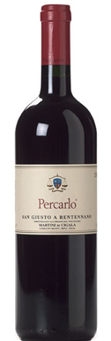
Percalo Igt 2004 Sangiovese di Toscana
Production n. 17.173 bottles of 75 cl – 960 Magnum of 150 cl and 30 Double Magnum of 300 cl
The vines enjoyed ideal weather conditions throughout the year. The grapes ripened gradually and perfectly and were picked later than usual.
During what we call “the green harvest “ between 40 and 50% of the spontaneous grape production was eliminated.
As a result of only using completely ripe grapes and carefully choosing the finest bunches from the best exposed vines on our estate, this wine is very long and has a high mineral content.

Best between 2007 and 2016 and beyond.

Serve at 17 to 18° C.

As this wine is unfiltered, you might find a slight deposit at the bottom of the bottle.

